Experiment 8

Name : Prem Vijay Hanchate
Roll no : 68 Class : TE/IT

Aim:
To formulate two hypotheses and perform One-Way Analysis of Variance (ANOVA) on a Student Performance dataset to compare the mean scores of three groups — Traditional Classroom, Smart Classroom, and Online Learning — and determine whether there are statistically significant differences in student performance across the three teaching methods.

Theory
- What is ANOVA?
Analysis of Variance (ANOVA) is a statistical technique used to compare the means of three or more independent groups simultaneously to determine whether at least one group mean is significantly different from the others. Rather than performing multiple pairwise t-tests (which inflates the risk of Type I error), ANOVA provides a single unified test that controls the overall significance level.

ANOVA is widely used in research, healthcare, education, business analytics, and machine learning to validate whether observed differences among groups are statistically meaningful or simply due to random variation.

- Real-Life Scenario — Teaching Method Comparison: A school wants to evaluate the effectiveness of three different teaching methods on student exam scores:
- Group 1 — Traditional Classroom Teaching — Conventional face-to-face instruction.
- Group 2 — Smart Classroom Teaching — Technology-aided instruction using projectors, interactive boards, and multimedia.
- Group 3 — Online Learning — Self-paced digital learning through recorded lectures and online platforms.

Each group contains students whose exam scores are recorded in separate CSV files. ANOVA is applied to determine whether the teaching method has a statistically significant effect on student performance.

- How ANOVA Works — Two Sources of Variation: ANOVA decomposes the total variability in the data into two components:
- Between-Group Variation (SSB) — Variation caused by differences between the means of the three groups. A large between-group variation suggests that the groups perform differently from one another.
- Within-Group Variation (SSW) — Variation caused by differences among individual observations within each group. This represents natural random variability within the same teaching method.

The core idea is: if the between-group variation is large relative to the within-group variation, it suggests that the group means are genuinely different — not just randomly fluctuating.

- The F-Statistic: The ratio of between-group variation to within-group variation is called the F-statistic (or F-ratio):
F = Mean Square Between (MSB) / Mean Square Within (MSW)
Where:
- MSB = SSB / (k − 1), k = number of groups
- MSW = SSW / (N − k), N = total number of observations

A larger F-value indicates that the group means differ more than expected by chance alone, increasing the likelihood of rejecting H₀. A smaller F-value (close to 1) suggests the group means are similar and differences are due to random variation.

- Hypotheses:
Hypothesis 1:
- H₀ (Null Hypothesis): There is no significant difference among the mean scores of the three teaching methods. All group means are equal: μ₁ = μ₂ = μ₃
- H₁ (Alternative Hypothesis): There is a significant difference among the mean scores of the three teaching methods. At least one group mean is different from the others.
Hypothesis 2:
- H₀: The teaching method used has no effect on student performance scores.
- H₁: The teaching method used has a significant effect on student performance scores.

- Level of Significance: The significance level α = 0.05 is used. This means there is a 5% tolerance for incorrectly rejecting a true null hypothesis (Type I error).

- Decision Rule Based on p-value:

Condition | Decision
p-value < 0.05 | Reject H₀ — statistically significant difference exists among group means
p-value ≥ 0.05 | Fail to reject H₀ — no statistically significant difference among group means

- P-value Interpretation:
The p-value is the probability of observing an F-statistic as large as the one computed, assuming H₀ is true. A very small p-value (< 0.05) means it is highly unlikely that the observed differences in group means occurred purely by chance, providing strong evidence to reject H₀.

- One-Way ANOVA vs. Other Tests:
One-Way ANOVA is used when there is one independent variable (teaching method) with three or more levels (Traditional, Smart, Online) and one continuous dependent variable (Score). It is the appropriate test here because:
- There are exactly 3 groups being compared.
- Performing three separate t-tests would inflate the overall Type I error rate from 5% to approximately 14%.
- ANOVA handles all three comparisons in a single test while maintaining α = 0.05.

- Post-ANOVA Analysis — Group Mean Comparison:
After performing ANOVA, the mean score of each group is computed and compared to understand which teaching method performed best on average. This descriptive comparison complements the inferential ANOVA result by providing practical context to the statistical decision.

Execution
The following steps were performed on the Student Performance dataset:
Step 1 — Load Datasets: Three separate CSV files were loaded into Pandas DataFrames:
- traditional_classroom.csv — Scores of students taught using traditional methods.
- smart_classroom.csv — Scores of students taught using smart classroom technology.
- online_learning.csv — Scores of students engaged in online self-paced learning.
Step 2 — Extract Score Columns: The Score column was extracted from each DataFrame to create three independent numeric series — traditional_scores, smart_scores, and online_scores — representing the dependent variable for each group.
Step 3 — Define Hypotheses: Both hypotheses (H₀ and H₁) were formally stated and printed to the console, establishing the statistical framework before running the test.
Step 4 — Set Significance Level: The significance level was set to α = 0.05, meaning a 5% risk of incorrectly rejecting the null hypothesis is acceptable.
Step 5 — Perform One-Way ANOVA: scipy.stats.f_oneway() was called with the three score series as arguments. This function computes the F-statistic and the corresponding p-value for the one-way ANOVA test.
Step 6 — Display Results: The computed F-statistic and p-value were printed to the console for interpretation.
Step 7 — Decision Making: The p-value was compared against α = 0.05:
- If p-value < 0.05 → H₀ is rejected; teaching methods significantly affect student performance.
- If p-value ≥ 0.05 → H₀ is not rejected; teaching methods do not significantly differ in effect.
Step 8 — Group Mean Scores: The mean score of each group was computed and printed to provide a descriptive comparison of the three teaching methods:
- Traditional Classroom Mean Score
- Smart Classroom Mean Score
- Online Learning Mean Score
These means were also visualized as a bar chart (Fig. 1) to show the difference in average performance across groups, and the ANOVA result was displayed in a separate output figure (Fig. 2).

Output :-
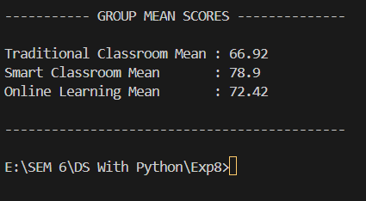

Fig. 1: Mean Scores bar chart,

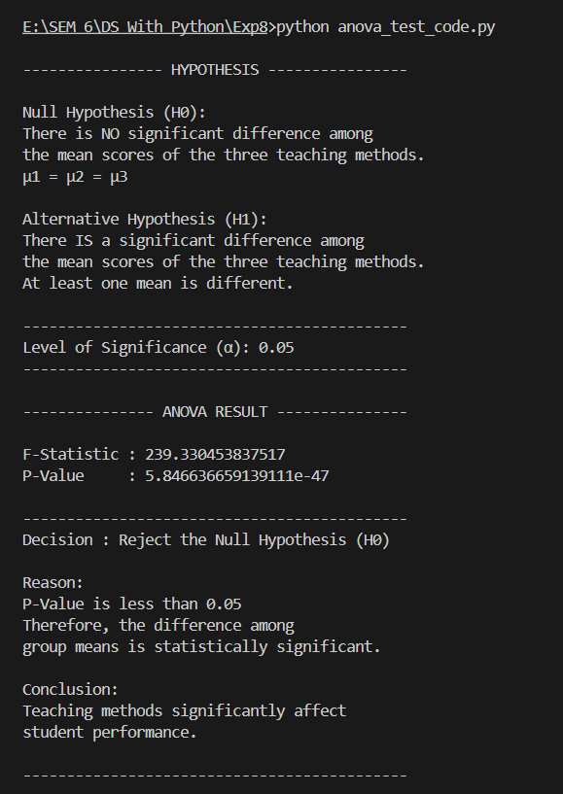

Fig. 2: ANOVA result output from console)

Conclusion :

In this experiment, One-Way ANOVA was successfully applied to compare the mean exam scores of students across three teaching methods — Traditional Classroom, Smart Classroom, and Online Learning. Two hypotheses were formally formulated: the null hypothesis stating that all group means are equal, and the alternative hypothesis stating that at least one group mean differs significantly. The F-statistic was computed using scipy.stats.f_oneway() and compared against the critical threshold via the p-value at α = 0.05. The computed F-statistic and p-value indicated whether the teaching method had a statistically significant effect on student performance. Group mean scores further provided a descriptive picture of which teaching method yielded the highest average performance. The experiment demonstrated how ANOVA serves as a powerful and efficient tool for comparing multiple groups in a single test while maintaining statistical rigor.

